

Transport Module

Requirements specification

Hadar Ovadia 208542449

Ilay Gov 318546280

# Functional Requirements

|  |  |  |  |  |  |
| --- | --- | --- | --- | --- | --- |
| ID | Module | Description | Priority | Risk | Status |
|  | Transport | The system **MUST** record every transportation. | MH | L |  |
|  | Transport | The system **MUST** record every item contract per destination. | MH | L |  |
|  | Transport | The system **MUST** record every site and save its properties. | MH | L |  |
|  | Transport | If a truck exceeds its weight limit, the system **MUST** alarm the user. | MH | L |  |
|  | Transport | The system **MUST** not allow a driver to be registered with a truck he doesn't have a license to. | MH | L |  |
|  | Transport | The system **CAN** allow changes in past records. | NTH | M |  |
|  | Transport | The system **MUST** show all the information about past records. | MH | L |  |
|  | Registration | The system must support registration and deletion of employees. | MH | L |  |
|  | Personal Details | The system will store the name, ID, bank account details, salary, working conditions, start working date and job role for each employee. | MH | L |  |
|  | Personal Details | The system shall allow modification of employee’s personal details | MH | L |  |
|  | Shifts | The system will store the shifts for each employee | MH | L |  |
|  | Shifts | A shift can be a morning shift or an evening shift only | MH | L |  |
|  | Shifts | A shift must contain the day of the week | MH | L |  |
|  | Shifts | A shift must have (at least)? 1 shift manager | MH | L |  |
|  | Shifts | A shift contains the number and type of employees that takes place in it | MH | L |  |
|  | Shifts | The system will store all shifts history | MH | L |  |
|  | Shifts | The system shall allow employee to read and modify its shift personal preferences | MH | L |  |
|  | Shifts | The system shall allow modification of shift roles and number of employees by the HR manager only | MH | L |  |
|  | Shifts | The system shall display all shift assignments on the “Assignment Screen” | MH | L |  |
|  | Shifts | An employee cant be assigned to a job that isn’t his role | MH | L |  |
|  | Shifts | The system will only allow the manager to assign employees to shifts and display the schedule for him | MH | L |  |
|  | Shifts | The system will store all shifts history | NTH | L |  |
|  | Shifts | The system will be able to display a weekly schedule of shifts for each employee | NTH | L |  |
|  |  | The system must not allow a shipment to arrive without Storage Employee present in the shift |  |  |  |
|  |  | The system must not allow a transportation to be executed if a driver isn’t present in the shift |  |  |  |

1. Terms

Table 1: Terms

|  |  |  |
| --- | --- | --- |
| **#** | **Term** | **Description** |
|  | Item Contract | The contract a driver receives per destination in a transportation. |
|  | Destination | A site which appears in an item contract. |
|  | Transportation | A shipment that contains source and one or more sites , item contracts, one driver and one track |
|  | Employee | A worker in super-li, contains all his personal details, and the shifts he prefer to work in. |
|  | Shift | Identified by Type(Morning or Evening) and date, contains its currents employees and constraints of how many employees of each type. |
|  | DailySchedule | Identified by Id, contains all shift in the day |

1. Open Questions

Table 2: Questions that have no impact on the current implementation

|  |  |  |
| --- | --- | --- |
| **#** | **Topic** | **Issue** |
|  | Persistence | Is the data going to be needed on different computers? (should the data be saved on a cloud for example?) |
|  | Persistence | Will the past documents be recorded in the new system? |
|  | Presentation | In what format should documents be represented? |
|  | Input restrictions | Can a transportation have multiple Transportation areas? |
|  | Presentation | How will be showed the assignment screen |
|  | Employee's personal details | What exactly are the employee conditions |

Table 3: Questions that impact the current implementation

|  |  |  |  |
| --- | --- | --- | --- |
| **#** | **Topic** | **Issue** | **Answer** |
|  | System Requirements | How should the change in a Contract be shown? | A new contract would be requested by the user and the old one would be marked. |
|  | System | Should our transportation module care about the details of item contracts? Or should it only know them by their identifiers? | In the current version of the program we will record as detailed as we can, and in the future after the merge with the other modules we will change it as necessary. |
|  | Transportations | Can an item contract be used in two different transportations? | No, an item contract should be only in one transportation. |

Version History

Table 2: Version History

|  |  |  |
| --- | --- | --- |
| **Date** | **Author** | **Remarks** |
| 19/03/2021 | Hadar Ovadia & Ilay Gov | First draft |
| 20/03/2021 | Hadar Ovadia & Ilay Gov | Completing requirements and terms tables |
| 21/03/2021 | Hadar Ovadia & Ilay Gov | Fixing according to Moodle forum answers |
| 22/03/2021 | Hadar Ovadia & Ilay Gov | Last changes |

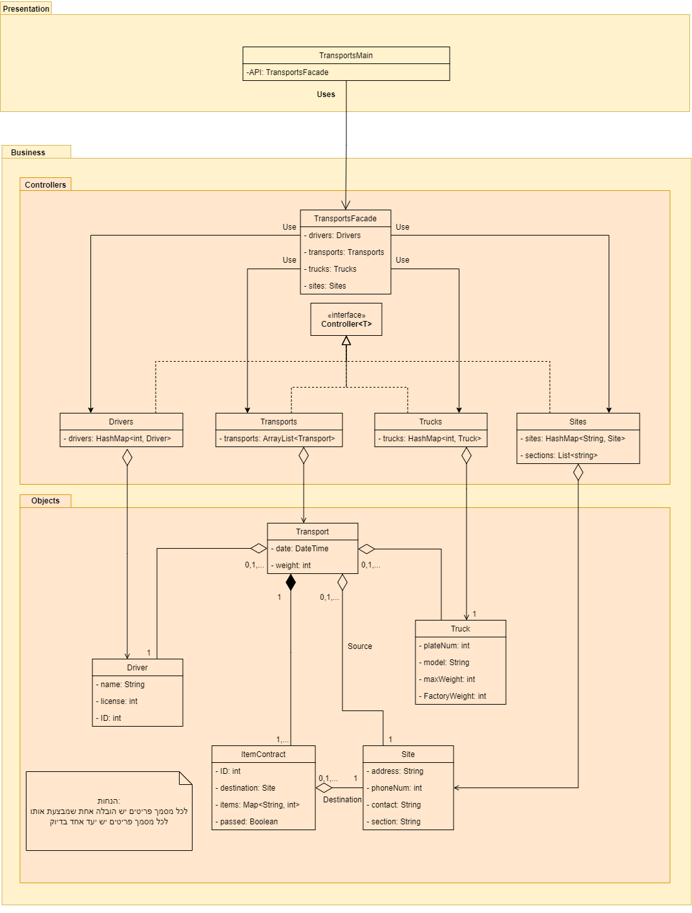

In the next object diagram, we show a scenario that would happen whenever a User plans a new transportation in the system. In this scenario the we have only one destination, Givatayim, transporting 1 "Tea". The weight is legal therefore it has "true" in the field passed. The driver has a license to the truck he is assigned to and therefore the transportation is recorded in the system.

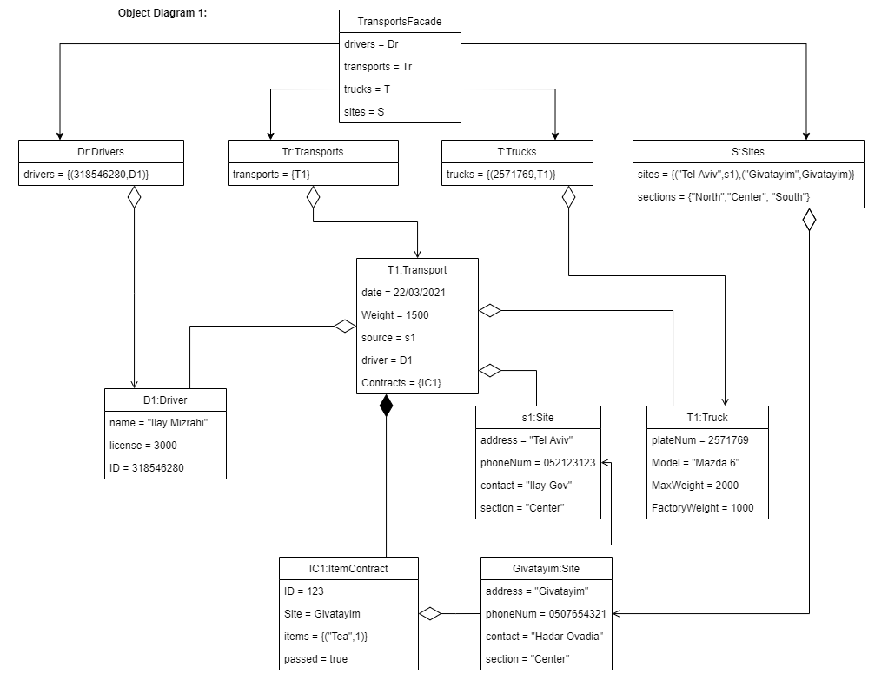

In the next object diagram, we show a scenario similar to the one before, however, this time there was an attempt to transport 8 "Tea"s! The weight limit was exceeded therefore it has "false" in passed field. The system requested a new Item Contract and was given one that had legal weight with 2 "Tea"s. We can see in this diagram that the past Item Contract was recorded and could be told apart from the one that had actually transpired (the one with "true").

